**A Deep Dive into Space Missions: Data Analysis and Visualization**

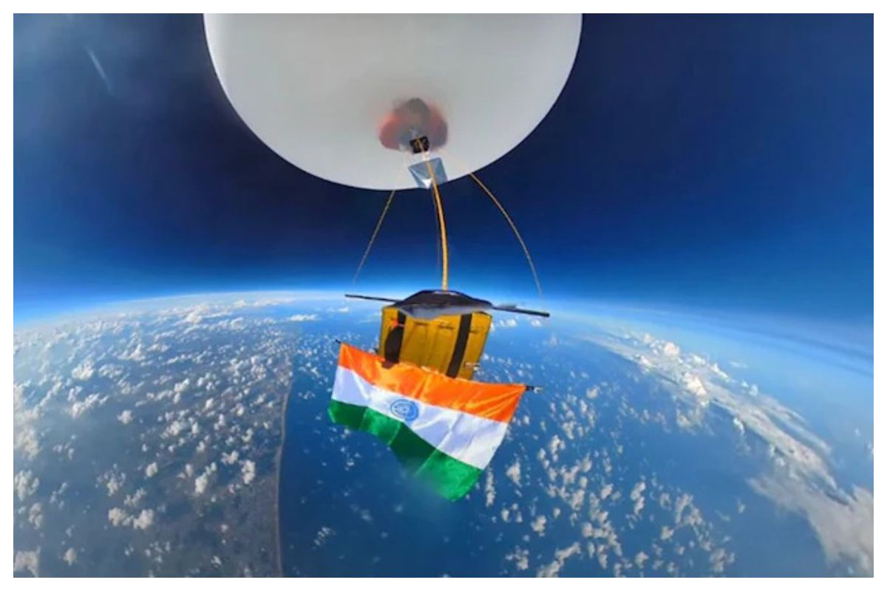

The potential to venture into space has been a source of fascination for me throughout various stages of my life. From my early years, I've been captivated by the mysteries of celestial objects visible in the night sky. The exploration of space holds a foundational significance in comprehending the physical universe. Scientists engage in space exploration to investigate the cosmos beyond Earth's atmosphere, utilizing the gathered information to enhance our understanding of the universe and contribute to the well-being of humanity. This exploration is typically carried out through both manned and unmanned spacecraft.

The Space data analysis was performed in Tableau. The Space Race datasets file used in this analysis is provided in the repository.

1. Data exploratory for Mission status

1. Rocket status

1. Various companies involved.

1. Space mission carried out each year.

1. Space mission popularity among months

1. Dashboard

**Synopsis**

Analysing datasets encompassing space missions dating back to the commencement of the Space Race in 1957, it becomes evident that a significant portion of these missions achieved success. The data highlights Russia and the USA as the predominant contributors to mission launches. Notably, RVSN USSR and Arianespace emerge as the leading companies actively involved in space missions. Furthermore, a temporal pattern is observed, indicating that a substantial number of space missions occurred during the mid-'60s to the late '70s.